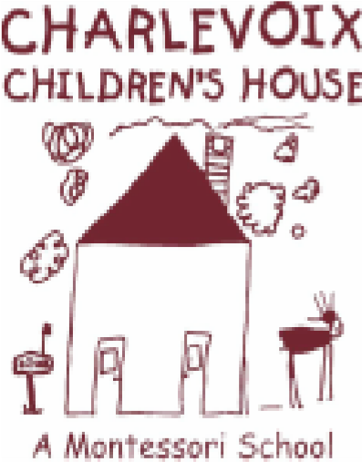
Minutes from:
Charlevoix Children’s House, Inc.
Executive Board Meeting
*approved
Date: 11/11/2019

Time: 6:00 pm
Location: Pigs Eatin Ribs
Board Members:
Present: Chris Matye, Jill Kline, Linda Zerby, Amanda Evans, Molly Vargas

Absent: Seth Arnold, Dianne Dreyer
Others Present: N/A
Proceedings:
- Meeting called to order at 6:06 p.m. by vice president, Chris Matye
- September and October meeting minutes approved by Matye and seconded by Zerby
- Matters for Decision
3.1 none
Action Item:
  - Treasurer’s Report: Jill Kline , updated financials
4.2 President’s Report/Building, Maintenance & Playground: Seth Arnold - absent
4.3. Vice President’s/Website& Marketing Report: Chris Matye
1. need gutters cleaned, will send out email for parent volunteers
2. need playground swings updated and also may need shed repairs.
  - Directress Report: Molly Vargas, Directress
      - We are up for state of Michigan licensing renewal
      - December 19th Christmas program at Charlevoix Public Library
  - Fundraising & Grant: Amanda Evans
- Fright Night Fundraising update and totals
- Giving Tuesday Facebook Campaign donation, set for Tuesday Dec 3rd
- Will be sending thank you notes sent to Fright Night sponsors
  - Social & Volunteer/Fundraising & Grant: Linda Zerby
- cottage pottery fundraiser- will contact Paige for weekend availability
- Charlevoix community foundation, awaiting update on donation
5.1 New Business:
5.2. Old Business:
Announcements: Next Board of Director’s meeting will be held on Monday December 9th at 6:00 pm at the Charlevoix Public Library in the Armstrong Room

Meeting adjourned at 7:50 p.m by Chris Matye
Meeting Minutes submitted by Secretary, Linda Zerby

